OFFICIAL NOTIFICATION FOR
NON-ROUTINE OPERATIONS AND MAINTENANCE

NOTIFICATION DATE- 09 February 2010
PROJECT- The Dalles
RESPONSE DATE- No response required, but comments are always welcome.

Description of the problem- There remains some uncertainty how much oil is still under the spill site. Oil was found in 4 drain holes leading into the sluiceway. Therefore we are required by regulating agencies to install the grout curtain to prevent further oil from entering the river via sluiceway. The planning team is working to complete in Feb, knowing that we want the sluiceway open 01 March for Battelle’s sluiceway research. However, the work could easily go into the first week of March. The sluiceway cannot be opened until this grout curtain has been installed. Therefore we are requesting to keep the sluiceway closed through March 8. Depending on progress, there may be a need for additional days.

Type of outage required- ITS closed through 8 March 2010.
The Contractor shall construct a grout curtain beneath and along the sides of the ice and trash sluiceway. The sluiceway is only accessible by crane. Because the sluiceway is only dewatered until 1 Mar 2010, work within the sluiceway is time critical. Sequencing of the work shall be grouting beneath the floor slab followed by grouting behind the walls. It is less desirable, but grouting of the sides could be done by angling grout holes down towards and intersect the sluiceway walls from above outside the sluiceway. Drilling from outside will require greater drilling depths.

The goal is to use controlled grouting techniques to create a narrow (5 ft) wide zone of grouted rock 30 feet deep beneath and around the sides of the sluiceway. Grouting pressures shall be tightly controlled to prevent damage to the concrete walls and floor slabs. Grouting volume shall also be tightly controlled to prevent migration beyond twice the width of the zone to prevent grout from penetrating into drains and into the nearby fishway. No more than one drain may be filled with grout.

The grout curtain shall be constructed beneath the riverward side of the sluiceway bridge. It may be necessary to do the work beneath the bridge because the abutment for the sluiceway across the fishway is located immediately downstream of the access bridge. The grout curtain shall be positioned immediately between two wall drains and run perpendicular to the sluiceway.
Impact on facility operation- The ITS will be closed and clean up crews will be installing a grout curtain around the Westrick Building.

Length of time for repairs- Unknown but could take a week or more into fish passage season.

Expected impacts on fish passage- The ITS will be closed while the grout work is underway. This will limit surface passage options and compromise the sluiceway adult passage study planned to start 1 March.

Comments from agencies- no comments required and none were submitted.

Final results- The oil clean up will continue as coordinated.

Tammy Mackey
NWP Operations Division Fishery Section
Columbia River Coordination Biologist
541-374-4552 Bonneville Office
503-961-5733 Blackberry
Tammy.m.mackey@usace.army.mil

J, K, L, M
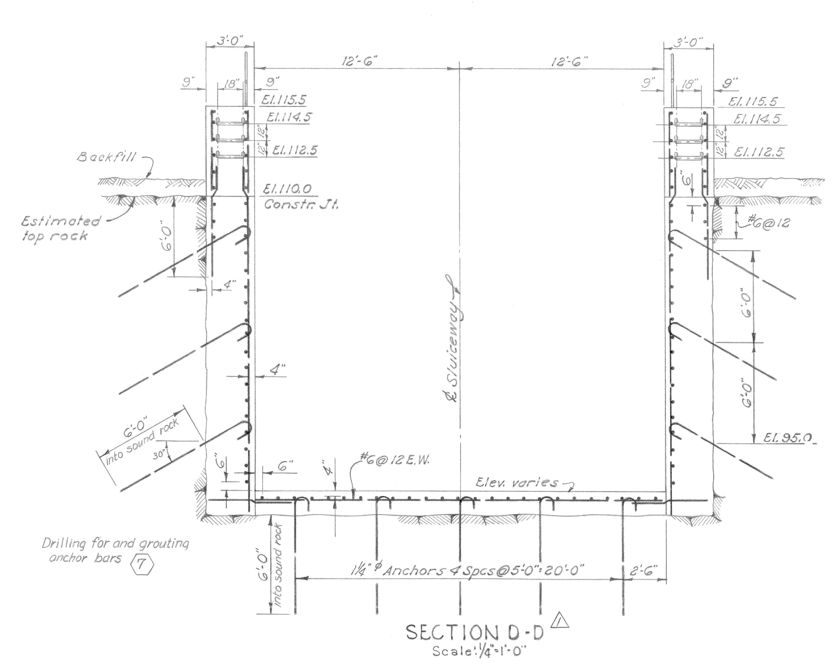

F
G
H
I
N
B,C,D,E
F
J,K,L,M
El. 85
P/Q Contact Zone
Grout Zone 2
El. 80

Primary Grout Holes

Secondary Grout Holes

Date: 1/22/10
From: Bob Cordie, Project Biologist, The Dalles Dam

Re; Contingency plan for The Dalles east fishway, south channel operation in the Westrick park oil spill recovery efforts

With the transformer spill in Westrick Park at close proximity to the south fishway channel, an unknown quantity of oil may be in the substrate in the immediate area. To date, no oil sheen has been observed in the channel. Close monitoring continues. There is a possibility of oil migrating into the channel during fish passage season, several months after the spill recovery efforts. Therefore this contingency plan will be presented as an alternative operation to allow oil recovery efforts.

Increased fishway inspection observations will be conducted immediately after the east fishway is returned to service to catch any oil sheen. This will be done during optimal lighting conditions at the Westrick building bridge and the south entrance area. If oil sheen is noted, the project ECC will immediately be notified.

If it is determined the volume of oil needs to be contained, the following operation may be implemented pending approval from regional fish managers.
- Shut down Fish unit 1 and 2.
- Install isolation bulkheads between powerhouse and south channel. This includes auxiliary water conduit bulkhead and channel bulkhead.
- Install south entrance bulkheads to isolate channel from river.
- Crane setup and structural prep work must be completed prior to fish unit shut down.
- Open all west and east entrance weirs to full open.
- Return fish unit operation to half load and slowly increase while monitoring east and west entrance flows.
- Maintain this operation during oil recovery efforts.

Fish Passage Data
Blue bars are flow percent flow volume. Maroon bars are percent passage.

Potential flow and fish passage affect;
South entrance passage ranges from 10-25% depending on species. South entrance flow is approximately 40% of total. If south entrance is closed, the 40% flow will be added to east and west entrances. However due to potential added pressure on fishway grating on east and west, the full 40% may not be used.
With added flow to the east and west, it’s possible the 10-25% south passage may be distributed to east and west without added overall dam passage delay. University of Idaho telemetry would be needed to verify potential overall passage delay.

